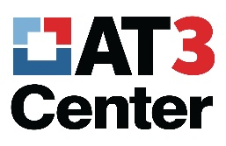
Assistive Technology Act
Technical Assistance & Training Center

State AT Program Leadership Symposium

New Directors Session

April 15, 2018
1:30 PM- 4:00 PM
(Registration 12:30 – 1:30)

1:30 – 2:00 Welcome and Introductions – Marty Exline, Amy Goldman, Kathy Laurin
- Length of tenure in your position?
- Your background – what did you do before?
- Structure – What is your lead/implementing agency?
- How are your state level services provided? –centrally/decentralized/contracted out?

2:00 – 2:15 Background of the Assistive Technology Act and expanding the AT reach in your state.

2:15 – 3:00 Program Operations
- Annual Progress Report
- Budgeting and Spending Requirements
- Fund Obligation and Liquidation
- Contracting and Other Agreements
- Advisory Councils

3:00 – 3:20 Joint Break with ATAP Board of Directors

3:20 – 4:00 Program Operations (continued)
Beyond the Symposium – How Can We Help?

4:00 Adjourn

